Week 0

Roll No: 241801323
Name: Yashwanth.S

Algorithm and flowchart
1.Calculate Area and Perimeter Write an Algorithm and draw a Flowchart to Calculate the area and perimeter of a square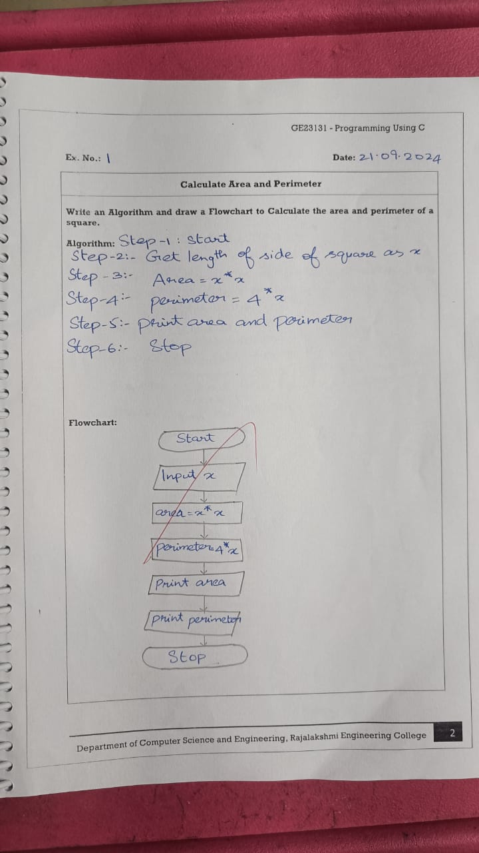

2.Days to Year Conversion
Write an Algorithm and draw a Flowchart to convert the given days into years & months

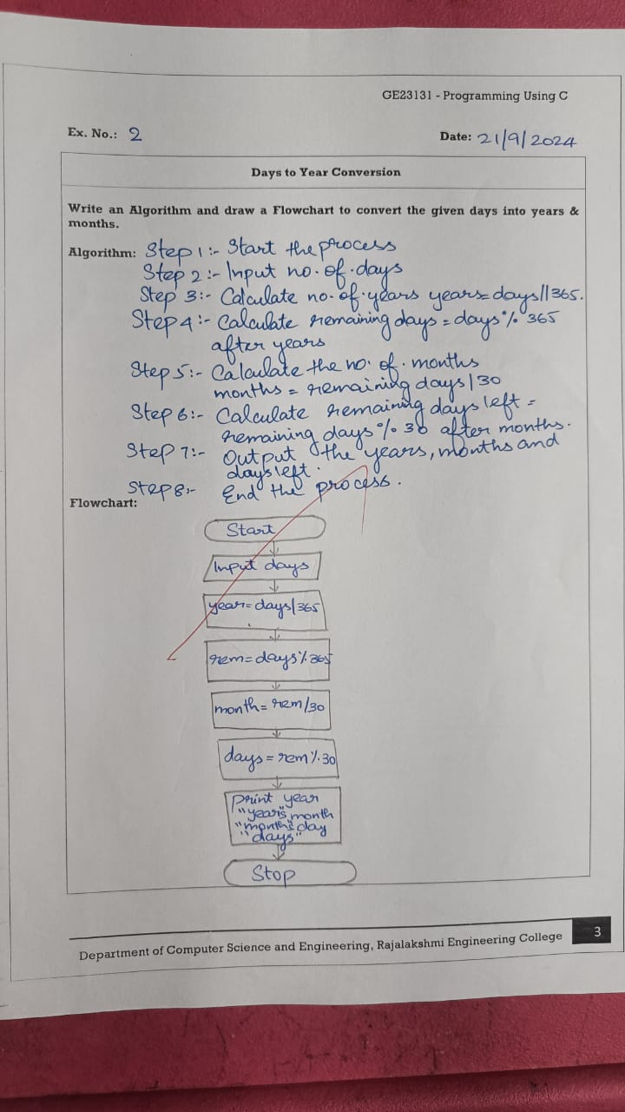

3.Prime Number
Write an Algorithm and draw a Flowchart to check whether the given number is Prime or not

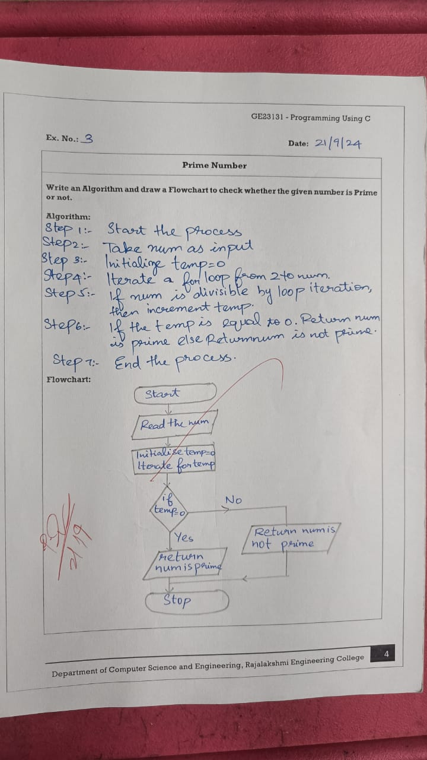

4.Leap Year
Write an Algorithm and draw a Flowchart to check whether the given year is Leap or not

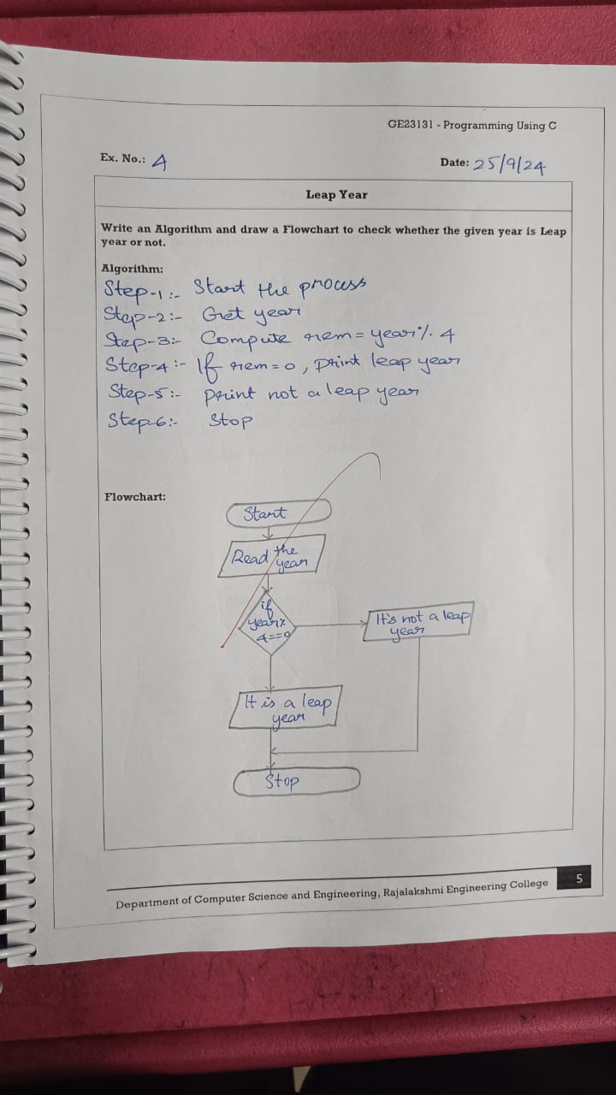

5.Palindrome Number
Write an Algorithm and draw a Flowchart to check whether the given number is Palindrome or not
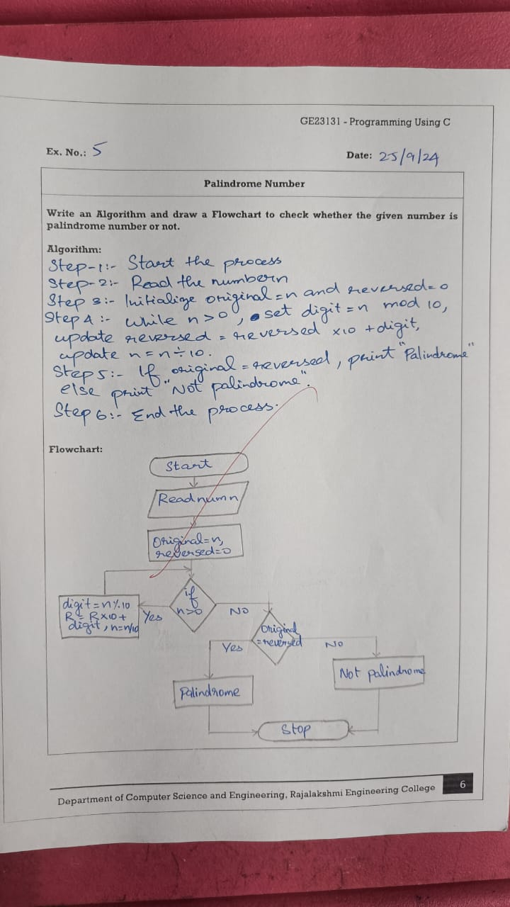
6. Sum of Digits
Write an Algorithm and draw a Flowchart to calculate the sum of digits in the given number
